AD LIFECYCLE ARTIFACT | External Design Document – V4.0  High Level Design
Application: OMS | Project Name: Market Knowledge
Author: Mike McCue | Project Code:
The External Design represents the high level functional specifications for your application based upon the approved business requirements.
2.01 - OVERVIEW 2
Out of Scope 3
2.02 - REQUIREMENTS TRACEABILITY MATRIX (Business Requirements to External) 3
2.04 – EXTERNAL DESIGN. 4
Conceptual approach 4
Process Flow 5
Process Details 6
Class Diagram - Domain Objects 7
Delivery Object – Intent and justification 8
Class Diagram – Inventory Management API and supporting classes 9
Collaboration Diagram – Get Venue Availability Data (this will need to be printed to be viewed easily) 10
Collaboration Diagram – Determine Release-ability 11
External System Dependencies and Interface Definitions 12
OMS to DMS 12
OMS to MMS 13
OMS to BRMS 14
2.05 - DESIGN ASSUMPTIONS 15
Cross Sub-System Message Transport layer 15
Sub-System Interfaces 15
Persistence 15
2.07 - DESIGN RISKS 16
Risks 16
XML Messaging 16
Performance 16
Reliance on BRMS 16
2.13 - TEST CASES 16
Interface test cases 16
2.14 - ERROR HANDLING 17
2.15 - NOTES 18
2.16 – EXTERNAL DESIGN SIGNOFF 19
2.17 - APPENDIXES 20

2.01 - OVERVIEW

This document covers the design of the (OMS) Inventory Management Service, which will be responsible for determining whether or not a delivery is releasable for Data Mart creation. Currently the IM process, which is evolving, is comprised of three steps: validation, venue data availability, and release-ability rules. This document will describe the IM component within this context - listing the steps of this process, the supporting objects, and the collaboration between the objects needed to implement the business process.

This document is technical but can illustrate the approach to the business. It gives a conceptual overview, but is intended to be used for translation by the development team to create further detailed designs as well as for implementation of its components. There are dependencies on infrastructure and services yet to be developed. Certain assumptions are made with regard to these dependencies to enable the completion of the design at least on the conceptual level. It is understood that these are risks, and therefore this design will change and evolve over time to match the realities of the environment and other sub-system team’s development. These risks and assumptions are identified and addressed in the appropriate sections further in the document.

The figure below depicts where IM fits within the overall Order Management System. 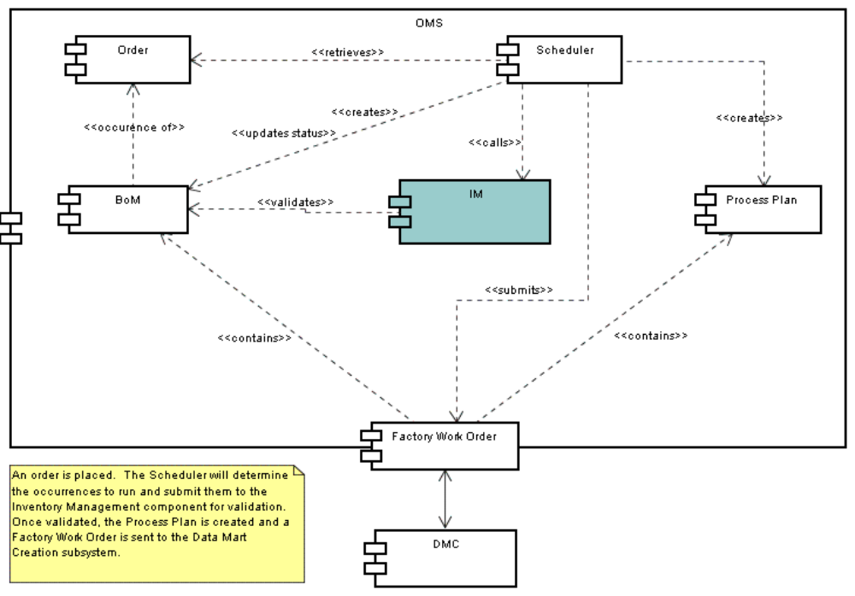
Out of Scope

2.02 - REQUIREMENTS TRACEABILITY MATRIX (Business Requirements to External)
This provides a cross-reference between the external design’s functional changes and the specific requirements referenced in the Business Requirements Documentation. Each functional change should be listed on a separate line in the table.

Req. # | Business Requirement | E.D. # | External Design Functional Change
 | FEAT 1787 – Feasability
 | FEAT 1796 – Feasabilty Notification
 | FEAT 1786 - Conduct Impact Analysis
 | UC 330 – Place an Order – Create an Order
 | UC 331 – Place an Order – Manage Delivery

2.04 – EXTERNAL DESIGN.

Conceptual approach
Inventory Management is conceived as a service that abstracts the implementation of business functionality which will determines data availability, delivery release-ability, as well as the impact of data changes (leading to restatement evaluation). Internally, for each one of these areas, IM will delegate the processing to any number of its components. This composite approach facilitates the ability of IM to service requests at a macro or micro level. For example, with such an approach, the IM service can easily separate out data availability checks, which will be needed at the time the order is placed, from a combination of release-ability and availability checks, which will be needed at order occurrence run time.

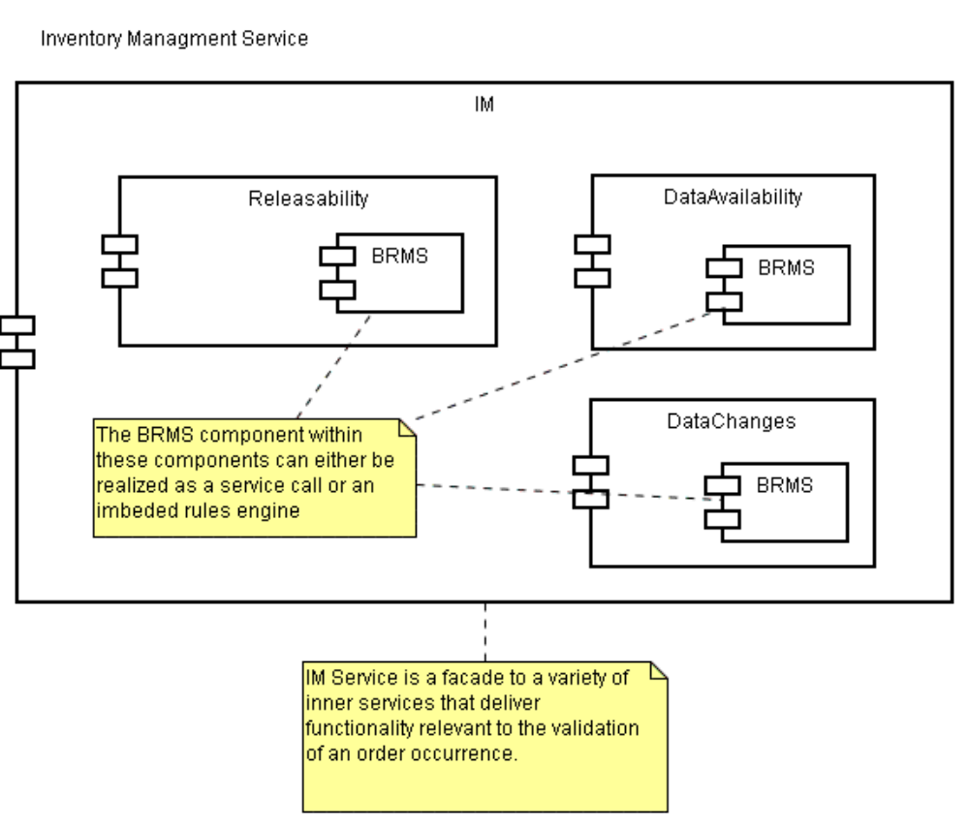

Process Flow
Based on current knowledge, the Inventory Management process is a simple set of steps that can be described using the diagram below. It is anticipated that this is will expand over time to include more functionality as more requirements become known.
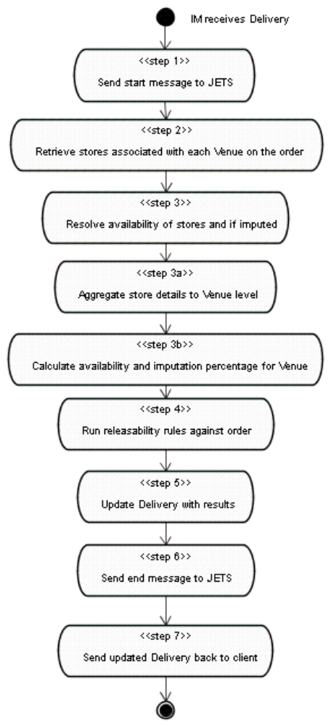

Process Details
For each step in the above table below describes the process at a more granular level. I have bolded significant domain objects to highlight their (first) appearance in the process. More detail about these objects is given further in the document.

Step | Name | Detail
initial | InventoryManager (IM) receives Delivery for validation | A client sends an instance of an order to be delivered for purposes of validation. For iteration 1, this means checking for data availability and release-ability rules. Data changes are out of scope for right now.
1 | Send start message to JETS | IM logs to JETS that the process is starting for this order (using the order id), specifying product type occurrence, i.e. POS, Market Insight etc, and delivery time periods. BOM id should be included in this message as well.
2 | Retrieve stores | IM sends Delivery instance to DataAvailabilityManager
 |  | DataAvailabilityManger retrieves Venues from order.
 |  | DataAvailabilityManager sends venue ids to DMS to resolve to Store
 |  | For each store DMS returns the store the id, x, y, and z. See section on DMS interface
 |  | DataAvailabilityManager puts store into Venue’s collection of stores.
 |  | IM sends Delivery to MMS. See section on DCS/MMS process.
 |  | For each store MMS returns if store is found and if it was imputed. The fact that the store record is found implies availability.
 |  | DataAvailbilityManager puts each store into Venue’s collection of stores
3 | Resolve data availability and imputation | DataAvailabilityManager sends Delivery to BRMS system. See section on BRMS interface for data availability.
3a | Aggregate store details to Venue levels | iLog Rules will be written to aggregate the stores up to the venue level.
3b | Calculate availability and imputation percentage for Venue | iLog Rules will be written specific to how availability and imputation percentages are calculated.
 |  | BRMS returns updated Delivery object to DataAvailabilityManager where each contained venue object has an availability flag and, if available, a imputation percentage.
 |  | DataAvailabilityManager returns Delivery instance back to IM.
4 | Run release-ability rules | IM passes Delivery instance to ReleasabilityManager
 |  | ReleasabilityManager passes Delivery instance to BRMS. See section on BRMS interface for release-ability.
 |  | iLog Business Object Model (BOM) will be written to represent the InfoScan product definition. iLog Rules will be written to fire against the Delivery instance, which will be considered an InfoScan product once in BRMS. The BOM design will map the Delivery’s parts and parameters to the literal names associated with InfoScan. These attributes originate with the product definition as it exists within the Selectica .kbs file. See section on BOM design.
5 | Update Delivery with results of release-ability check | BRMS updates Delivery instance with results of release-ability test, Y or N, and a reason code.
 |  | BRMS sends Delivery instance back to ReleasabilityManager.
 |  | ReleaseabilityManager passes updated Delivery back to InventoryManager
6 | Send end message to JETS | IM logs to JETS that the process is ending for this order (using the order id), specifying product type occurrence, i.e. POS, Market Insight etc, and delivery time periods.
7 | Send updated Delivery back to client | The updated Delivery, which now has release-ability status and a reason code, as well as Venues with availability and imputation levels, is sent back to the calling client.

Class Diagram - Domain Objects
This picture shows the objects relevant to the process.
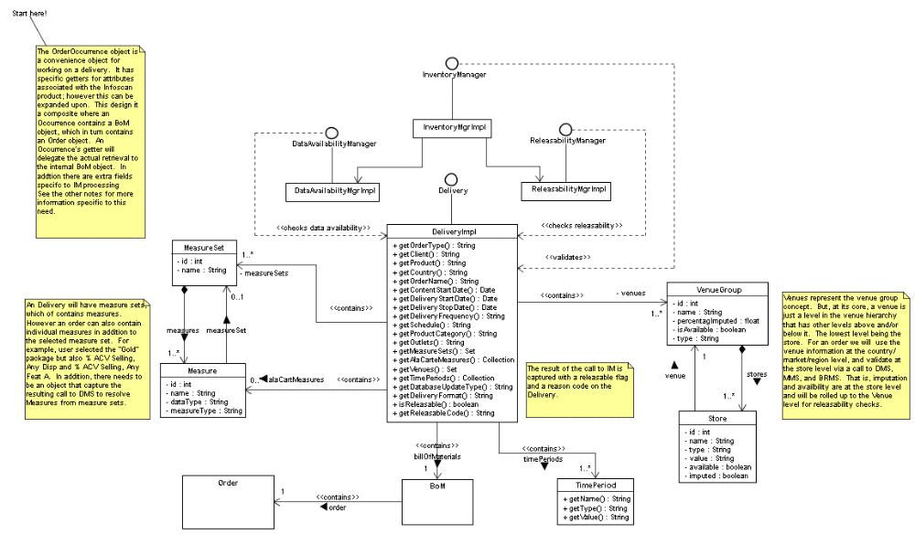

Delivery Object and BRMS BOM
Within OMS product definitions are captured by Selectica knowledge-base (*.kbs) files. These XML files capture the attributes associated with a product such as InfoScan. These attributes can be variable across and even within products. This variability is handled in the database as “product instances” and associated java object model as Orders and BoMs that have parts and parameters, where the number and type of parts and parameters can vary per product instance.
This is a flexible and scalable approach to a complex problem however it forces clients of the java objects to have knowledge of product definitions in order to retrieve and perform logic specific attributes. The intent of the Delivery object is to capture the common attributes as they are currently known and provide specific typed ‘getter’ methods to retrieve their values. In addition this object provides a concrete API to an order occurrence’s attributes where if necessary the methods can be discovered via java reflection. This object is central in simplifying the IM process.
The Business Rules Management System will be heavily leveraged in performing business logic on Deliveries. To facilitate this, specific product definitions will also need to be defined in the BRMS system as Business Object Models; the BOMs will need to match the Selectica *.kbs for each product defined. The Delivery object will be used as the value object that transfers information about the order occurrence. The BOM will ‘map’ to the internal parts and parameters of a delivery allowing for rule sets to be defined for specific product definitions.
To summarize, Selectica defines a product, the OMS structure allows for flexible storage of product instances, the Delivery object provides a convenience for downstream processes to work with product attributes, and the BRMS BOM provides addition mapping of rule sets to specific product types for the purposes of business rule execution.

Class Diagram – Inventory Management API and supporting classes
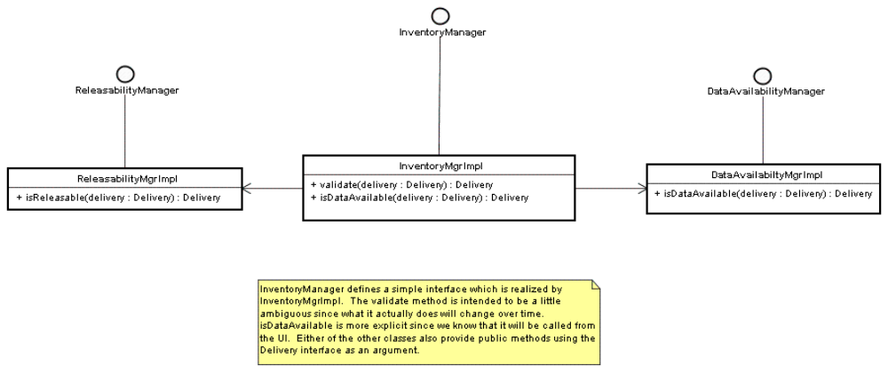

Collaboration Diagram – Get Venue Availability Data (this will need to be printed to be viewed easily)
This diagram illustrates the collaboration between objects in getting a venue’s availability data. Steps 2 – 3b. 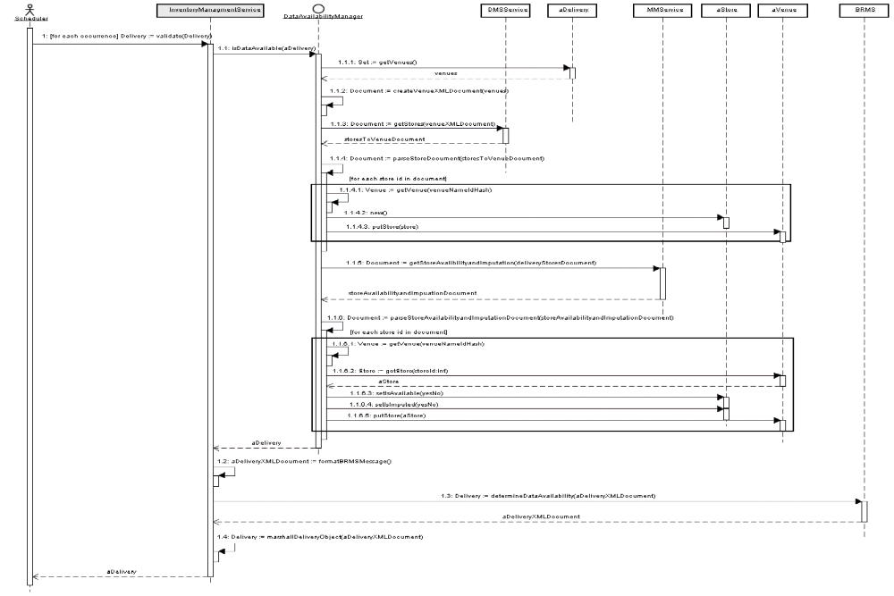

Collaboration Diagram – Determine Release-ability
This diagram illustrates collaboration between objects in determining a venue’s release-ability.

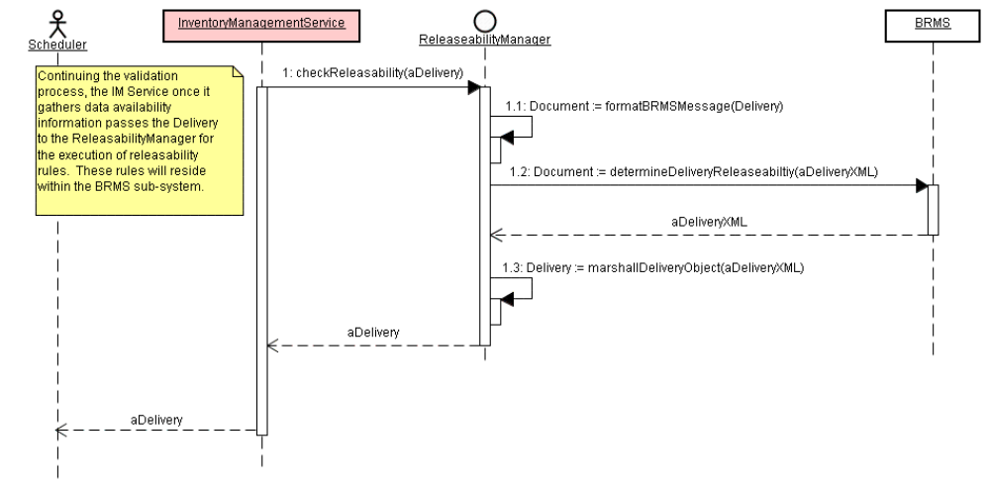

External System Dependencies and Interface Definitions

OMS to DMS
An order placed in the OMS system will have venue groups associated with it. These venue groups are stored in the OMS Order database at the country, region, or market level but without the store definitions. The store definitions are needed for the IM process since availability and imputation is captured by DCS (see OMS to MMS below) at that level. Later iterations might have users picking individual stores for an order (see Define Product Use Case) which would create the need for the stores in the LOP database. If this is the case the need for this interface is removed. But as of this writing it is out of scope.

In the list of parts database, a venue group will either be a country, region, or market. Each venue group, as defined in an order, can be resolved to its contained store(s) by using the vg’s id, type, and time frame, since the groups will be versioned in DMS. The exact interface to DMS is not yet defined; however based on conversations with the DMS team some assumptions can be made:

- A minimal set of data per venue group will be needed from OMS, i.e. id, type, and time frame in order to receive back a list of stores.
- Although DMS owns the associations from venue group to stores, there is currently no logic implemented on the DMS side to pass back stores with a reference to its parent venue group. This will be captured as a requirement and implemented by the DMS team.
- OMS and DMS will communicate using the to-be implemented service bus using XML messages for communicating back and forth. The format could look something like this:

File sent (excerpt)
<venue_group id=”123” type=”market” startTime=”6-1-2002” endTime=”6-1-2006” />
<venue_group id=”234” type=”market” startTime=”6-1-2002” endTime=”6-1-2006” />
.
.
.
<venue_group id=”456” type=”market” startTime=”6-1-2002” endTime=”6-1-2006” />

File received
<store id=456 time_id=xxx name=Albertsons venue_group=123 />
<store id=567 time_id=xxx name=Piggly Wiggly venue_group=234 />
.
.
.
<store id=678 time_id=xxx name=Jewel venue_group=456/>

- DMS will provide a (Java) layer on top of their current implementation of Oracle stored procedures.
  - Short term OMS to DMS solution might be to directly call the stored procedures, eventually migrating to future interface layer (ESB) once implemented.

OMS to MMS
The purpose of this interface is retrieve store meta-data, specifically the flags associated with store availability and imputation. Data Cleansing and Scrubbing receives the raw data and processes it through the DataStage tool. Based on meetings with DCS and MMS team members, a new job will be added to DataStage process that will extract and store the information needed for the IM process. OMS will interface with an MMS service to query the results of this extraction. This exchange is illustrated below:

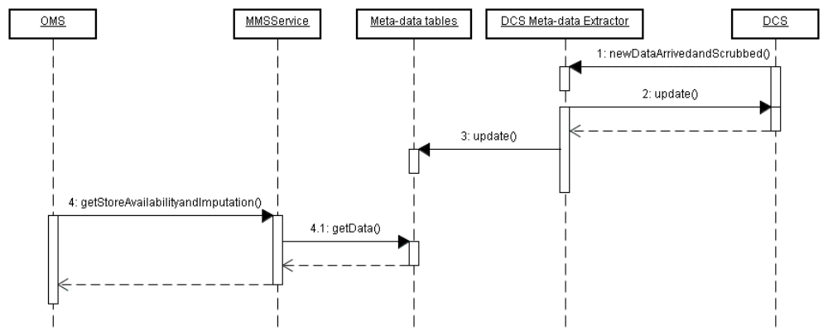
The DCS to MMS process as well as the OMS MMS interface are yet to be implemented; however based on conversations and verbal commitments some assumptions can be made:

- The transport layer between OMS and MMS will be the (to be implemented) enterprise service bus.
- The MMS meta-data table structure will have the following fields:

time_id venue_id status timestamp total_units

- The OMS to MMS message format needs to be defined but will need to be in XML format and consist of a minimal set of information. A proposed format looks something like this:

File sent to service:
<store id=456 time_id=xxx venue_group=123 />
<store id=567 time_id=xxx venue_group=234 />
.
.
.
<store id=678 time_id=xxx venue_group=456/>

File received
<store id=456 time_id=xxx status=xxx total_units=0078 available=y imputed=n venue_group=123 />
<store id=567 time_id=xxx status=xxx total_units=0078 available=y imputed=n venue_group=234 />
.
.
.
<store id=678 time_id=xxx status=xxx total_units=0078 available=y imputed=n venue_group=456/>

OMS to BRMS
Much of the logic associated with data availability and release-ability rules will be housed within the BRMS system. As of this writing the details of how OMS will interface with BRMS is being worked out but basically there are two options: IM makes a remote call to the BRMS system, passing the necessary information; or embed the rules engine within the OMS application. Based upon current knowledge and conversations with the BRMS team, the following approach is proposed:
- For performance reasons, use an embedded rules engine/set of rules for determining availability status.
- Since release-ability rules have enterprise scope and are not specific to OMS, make remote call for the release-ability step of the IM process.
- A Business Object Model hierarchy that represents the MK product definitions will need to be created. Currently the only product is InfoScan, however, this could expand in the future to be a number of different product or product variations. The product definitions will need to match the ones defined in the Selectica .kbs files used while Defining a Product.
  - The BOM will be an abstraction of the OMS Delivery, mapping specific product attributes to the parts and parameters of the Delivery for the purposes of firing product specific rule sets.
- Once the model is created, the remote call will consist of a schema that tells BRMS how to read the data, the rule set id to be fired against the data, and the data to fire rules against.
  - XML will be used to communicate the request.
  - The data portion of the message sent to BRMS will be a Delivery object represented as XML.
  - The exact format of the whole message needs to be defined.
- The response will be a Delivery object represented as XML, with the appropriate fields filled out that indicate the result of rules execution.

2.05 - DESIGN ASSUMPTIONS

Cross Sub-System Message Transport layer
The current momentum for standards of communication between sub-systems is an Enterprise Service Bus. This will be a tremendous boost to MK productivity and manageability, enabling teams to forget about mechanisms of communication and focus on format and content. However, this has yet to be widely implemented (beyond JETS) and widely accepted by the various teams. Based on architecture meetings and conversations the assumption is that we are moving in this direction and therefore all messages between systems will through the ESB and be in XML format.

Sub-System Interfaces
With regards to dependencies with other systems there have been meetings, documents, conversations, and emails exchanged to communicate ideas and solutions. There is an assumption that other teams will commit ideas/solutions to plans, as well as commit to the idea of communicating on through ESB.

Persistence
Inventory Management, as a service, should be stateless. Information relevant to the delivery is gathered, compiled with the original delivery and evaluated for release-ability, but at no point needs to be persisted. This design point is under assumptions since I am assuming the throughput will be manageable enough to require clients to handle the resending of the request in the event of some kind of error. Prototypes will need to be developed to test early and get a more accurate picture of the throughput, but, for right now, there is no immediate business or technical reason to persist the data at any point in the process.

2.07 - DESIGN RISKS

Data Volume and with venue availability
There needs to be an assessment of the amount of data associated with venues. If significantly large, then calls to the DMS Service to get all the stores where the data is then put in java objects on the heap, where they are put as arguments into another service call to DMS, might be significant in terms of performance. Especially since there will be marshalling and un-marshalling of these objects into XML documents for messaging.

XML Messaging / ESB
Assumptions are made that all messages between sub-systems will be made using XML and the ESB transport layer. The risk here is that designs and implementation will be done under this assumption and the infrastructure won’t be ready, and/or other system teams will not be ready or compliant.

Reliance on BRMS
The business logic required for data availability and release-ability will be in BRMS. This requires design but also implementation effort. Resource(s) will be needed who know the tool to implement the appropriate BOM’s as well as write the logic to be executed. Currently this expertise is limited.

Refactoring
The Delivery provides an interface that fills a need for IM processes but is also intended for use by other clients in using the IM service, e.g. getting data availability when committing a draft order to an actual order. If there is a more elegant design, then it needs to be discovered and designed for quickly. The risk is that efforts move forward with other teams (BRMS) to used this object and it then changes in later iterations.

2.13 - TEST CASES

Data Availability
Forthcoming.

Release-ability
Forthcoming.

2.14 - ERROR HANDLING

2.16 – EXTERNAL DESIGN SIGNOFF
This section should list each functional area and representative that needs to approve the External Design in order for AD to proceed with the ‘Build’ process (internal design, coding, testing). Executive sponsors, project managers, ITO, representatives of affected application and User functional areas, etc. should be included

The functional areas listed below are examples. Add and delete as appropriate.

Signoff - Name | Functional Area | Signoff Date
 | Project Sponsor −
 | Executive Sponsor −
 | Marketing & Consulting Services
 | InfoScan Product Management
 | AD – Order Processing
 | AD − Dictionary
 | AD – Delivery
 | AD – Projections
 | AD − Data loading
 | Commercial Software
 | Database Services − Support Groups
 | Database Services − Operations Control
 | Database Services − Requirements
 | Database Services − Requirements
 | Database Services − Data Input
 | France
 | Italy
 | Germany
 | UK
 | Holland
 | Spain
 | ITO
 | Mosaic InfoForce Partners
 | Project Initiation
 | Project Manager
 | QA
 | R&D
 | RDA
 | Sales Planning & Operations
 | Sampling & Projection

2.17 - APPENDIXES

